**Q1: Comment on skewness**

**Q2: Create and interpret histogram**

**Q3: Describe using boxplot**

**Q4: Correlation between age and score**

**Q5: Create a bar chart for preferred language.**

**Q6: Frame a storytelling insight from this data.**

**Q1: Comment on skewness**

Skewness is used to measure the asymmetry of data distribution.  
There are two types of skewness.  
1. Positive skewed. [Right] Mean>Median>Mode  
2. Left Skewed. [Left] MODE>MEDIAN>MEAN

* Symmetric “Mean, Median, Mode all are equal

**Q2: Create and interpret histogram**

A histogram is a graphical representation of a frequency distribution for a set of continuous numerical data

**Q3: Describe using boxplot**

A box chart (or box plot/box-and-whisker plot) is a graphical tool that visualizes the distribution of numerical data using its five-number summary: minimum, first quartile (Q1), median, third quartile (Q3), and maximum. The "box" represents the interquartile range (IQR), showing the middle 50% of the data, while the "whiskers" extend from the box to the minimum and maximum data points, indicating overall data spread. Box plots are excellent for comparing distributions across different groups, quickly showing the data's central tendency, variability, symmetry, skewness, and potential outliers.

Key Components

* **Minimum:** The smallest value in the dataset, excluding outliers.
* **First Quartile (Q1):** The 25th percentile, meaning 25% of the data falls below this value.
* **Median (Q2):** The middle value of the dataset, dividing it into two equal halves.
* **Third Quartile (Q3):** The 75th percentile, meaning 75% of the data falls below this value.
* **Maximum:** The largest value in the dataset, excluding outliers.
* **Interquartile Range (IQR):** The range between Q1 and Q3, which contains the middle 50% of the data.
* **Whiskers:** Lines extending from the box that show the range of the data, typically reaching to the minimum and maximum values excluding outliers.
* **Outliers:** Individual data points that lie far outside the whiskers, often considered unusual observations.

What a Box Chart Shows

* **Central Tendency:**

The median provides the center of the data.

* **Variability:**

The length of the box (IQR) and the whiskers indicate how spread out the data is.

* **Symmetry and Skewness:**

The position of the median within the box and the lengths of the whiskers reveal if the data distribution is symmetrical or skewed.

* **Outliers:**

Individual points plotted outside the whiskers highlight potential extreme or unusual values in the dataset.

When to Use a Box Chart

* **Comparing Distributions:** Box charts are ideal for visually comparing the distribution of data across multiple categories or groups.
* **Summarizing Data:** They offer a compact way to summarize large datasets.
* **Identifying Outliers:** They quickly pinpoint unusual data points that might require further investigation.

**Q4: Correlation between age and score**

=CORREL(C2:C9,D2:D9)  
-0.323319344 Negative skewness MODE>MEDIAN>MEAN

**Q5: Create a bar chart for preferred language.**

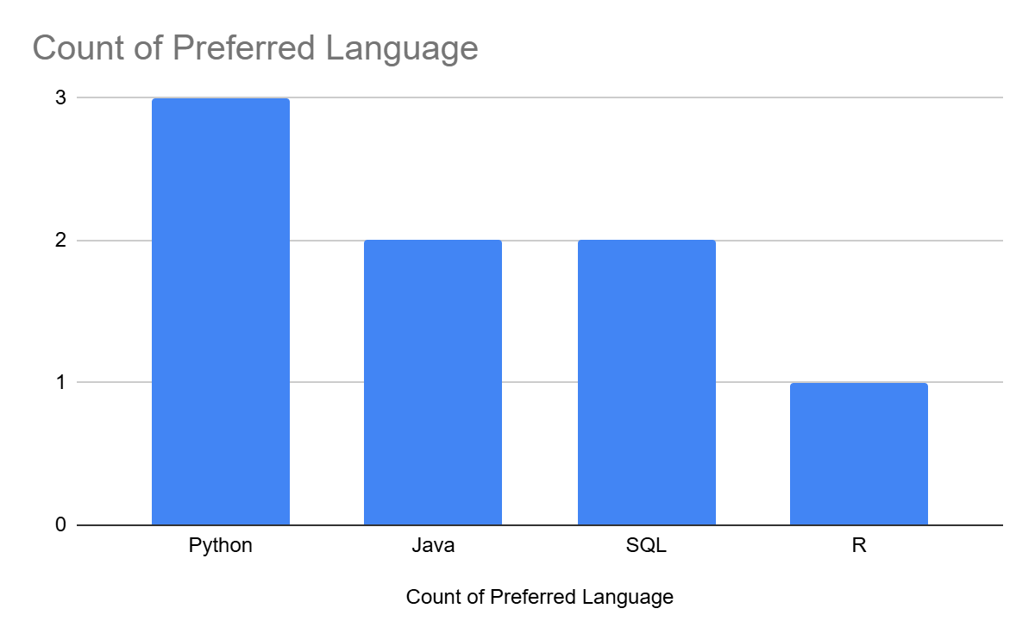

**Q6: Frame a storytelling insight from this data.**

**StoryTelling is a approach for insight of data, Explain the key elements like DATA,VISUALS,NARRTIVE.**